TABLE OF CONTENTS
- Important reminders
- Before you start - clear the cache
- How to access the EMR
- How to login
- Welcome page
- Registering a patient and a treatment
- Entering and saving data
- How to logout
- FAQs

I. IMPORTANT REMINDERS
- LOCATE ALL DATA FORMS to be entered for the day first before starting data entry into the EMR.
- USE THE LATEST VERSION OF ‘GOOGLE CHROME’ TO ACCESS THE EMR.
- KEEP YOUR PASSWORD SECRET AND DO NOT SHARE THIS PASSWORD WITH ANYONE. Only those with a username and password are permitted to log into the EMR. Please be respectful of patient confidentiality.
- All fields marked with a red star (ASTERISK *) ARE REQUIRED FIELDS. If any field with the asterisk is left empty, data entered on that form will not be saved.
- VERIFY DURING DATE ENTRY THAT DATES ARE CAPTURED CORRECTLY because dates on the paper forms are displayed as DD/MMM/YYYY and computers sometimes display date formats differently (can consider setting the computer operating system to be dd/mmm/yyyy).
- When registering a new or searching for an existing Patient EMR ID#, make sure the ID is entered as follows: Country ISO code (standard 3 capital letters) – Registration facility code (3 numbers assigned to the facility) – Consecutive patient code (5 numbers assigned to each patient, non repeating per registration facility). For example: LSO-001-00001. Note that the “-” should also be entered. ONCE THIS PATIENT EMR ID# IS SAVED, IT CANNOT BE CHANGED.
- Before entry, make sure that the form you are entering has not already been started by another data officer. FOR A FORM THAT HAS ALREADY BEEN SAVED: go to the “Dashboard” to update/edit the form. FOR A FORM THAT IS NEW: go to “Enter Data” to start a new form.
- After data entry into EMR, please put your INITIALS NEXT TO THE FIELD THAT HAVE BEEN ENTERED so others know this data has been entered.
- IF THERE ARE MISSING/INACCURATE FIELDS IN THE FORM, please mark the field clearly as a reminder to discuss with the clinician who filled out the form. Issues should be resolved within 3 days and updated data entered into EMR within 1 week. It is recommended that all data entry spaces have 3 data form trays: 1) “to be entered into EMR” tray, 2) “to be resolved with clinicians” tray, 3) “to file away” tray.
- IF EXACT MONTH AND DAY OF BIRTH IS NOT KNOWN, ENTER “JULY 1” AND CHECK “Estimated” next to Date of Birth.
- If the system seems to be running very slowly, please save your data, logout, wait 1 minute, and then log back in to see if the system functions better.
- LABS: the EMR is programmed to detect “abnormal” values according to MALE NORMAL RANGES ONLY. If the patient is a female or child, values that turn red signifying an out-of-range value may not apply. Note: lab values must be in the units specified in the EMR for entry; if a lab uses a different unit, manually convert the lab value to the desired unit in EMR.
- MONTHLY TREATMENT COMPLETENESS: Monthly assessment should be FROM 1ST OF MONTH UNTIL THE END OF THE MONTH (e.g. whole month of January or whole month of February), not from mid-month to mid-month.
- DO NOT USE THE “EXPORT” BUTTON FOR NOW because this feature is not yet complete.
- SAVE YOUR DATA OFTEN: Always remember to save your work before navigating away from the page your are working on by clicking on “Save”. Forgetting to do this will result in data loss. If you have to step away from the EMR for more than 10 minutes, save your work and logout of the EMR before stepping away. Log back in when you’re ready to enter data again.
- REPORTING AN ISSUE OR QUESTION:
  - Notify your data manager when there’s an issue with EMR.
  - Try to reproduce the error and take screenshots.
  - Briefly explain how you got the error and what you were trying to accomplish.
  - Send an email to jmbabazi@pih.org and jjwang@pih.org describing the issue and attaching the error screenshots. James and JJ will respond with solution as soon as possible.
  - If you CANNOT PERFORM DATA ENTRY AND SAVE because of this error, add the word **Blocker** to your e-mail subject so we can address this ASAP.

II. BEFORE YOU START, CLEAR THE CACHE
If you have trouble accessing the EMR link or when you notice that the browser (i.e. Google Chrome) is running slowly, clear your browser’s cache.

To clear the cache in Google Chrome:
- Press ctrl + shift + del, or go to “Settings” and click on “Show advanced settings…”
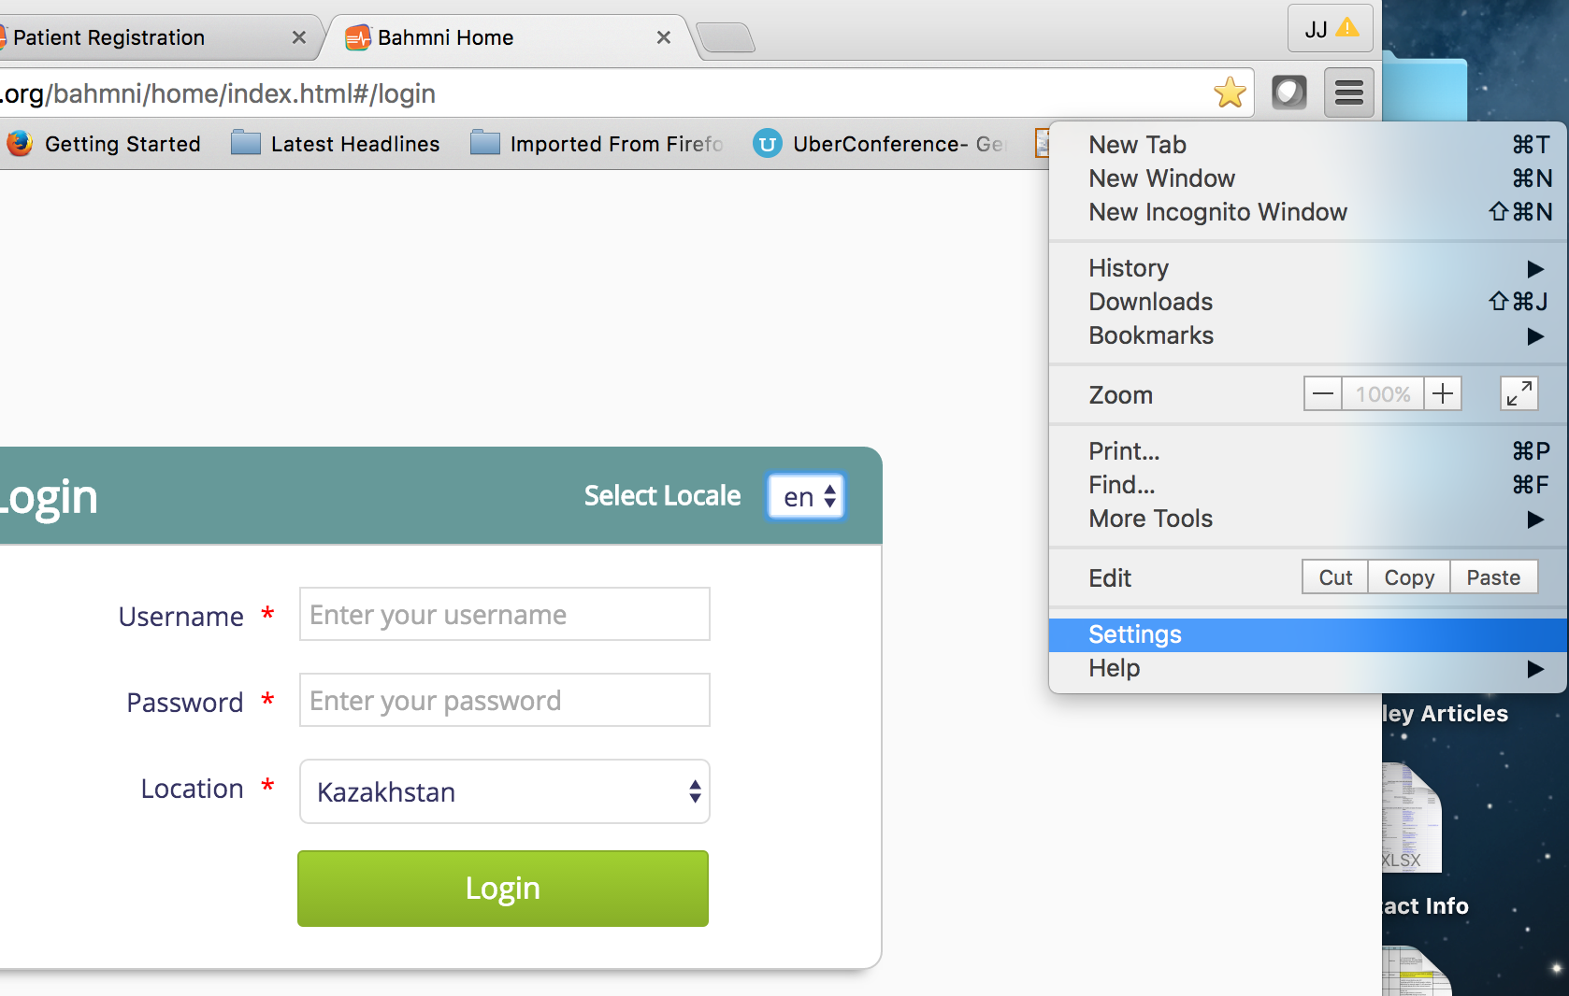
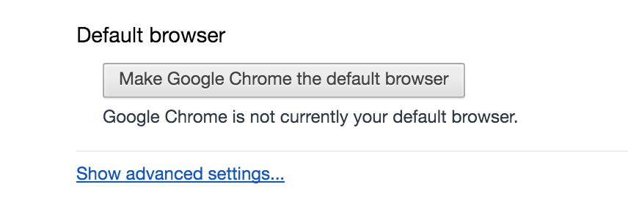
- Under “Privacy”, click on “Clear browsing data...”
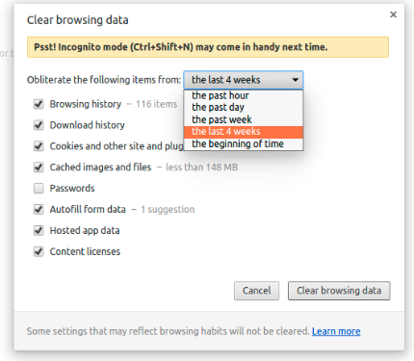

- Choose the time range you’d like to clear.
- Select “Cached images and files” only. Ideally only cache has to be removed. If we remove all data, we will lose the history and cookies as well, which is not needed
- Click on Clear browsing data.
Internal reminders:
- Site feedback process: Katya emails James & JJ (include screenshots, time and how issue happened etc.); James to record a ticket in both FreshDesk and PIH system; James will email Katya back with fix outcome
- There may be more fields in EMR that Kaz v7 forms are not collecting

Add to Training:
- The “DR-TB National ID#” in the Baseline form = “Registration #” in EMR for Treatment ID.
- If started a form by accident, enter just a date and “Invalid form” and fill out later
- Non-TB Drugs: To enter drugs taken continuously for the rest of a patient’s life, like blood pressure meds, enter a number in “Duration” that will outspan a patient’s life (since Duration is required), then just stop it when it is ever stopped
- In Exports, “Encounter Created Date” is the date that data was entered (not visit date)
- Extra training on SAE & Pregnancy form data entry because formatting so different and not all data entered in EMR, results are fed from PV Unit Summary
- Mention Tx Completion form - bug (rare event):
  - Tx Completion rates: to get around the situation where you have the number of ideal days is equal to the number of non prescribed days (for example a patient who has had his treatment suspended for the whole month due to raised liver enzymes), the data manager will enter the completion rate of 0% and adherence rate of 100% directly. They will not be the individual day data (which would lead the database to do the calculation).National ID # vs. “Registration #” (=treatment ID)
- AE form data entry: find the AE form that’s been saved, keep adding review log, and outcome to the same form for the same AE after 3 months of monitoring AE
- SAE form - several sections after initial opening section that PV Unit will provide in a summary at the end for import/entry by data officer
- Lab units: only enter data in left column where local units are, normal range is of Males.

III. HOW TO ACCESS THE EMR
Using the latest version of Google Chrome, the Kazakhstan EMR can be accessed here: https://kazakhstan.pih-emr.org/bahmni/home/index.html#/login

IV. HOW TO LOGIN
The first screen you will be presented is the login page. You should select your language of preference, enter your Username, Password, and Location, then click “Login” to begin using the EMR.

Note: the system default language is English; to change to another language:
- Click on the drop down button next to “Select Locale” and choose your preferred language prior to clicking “Login”
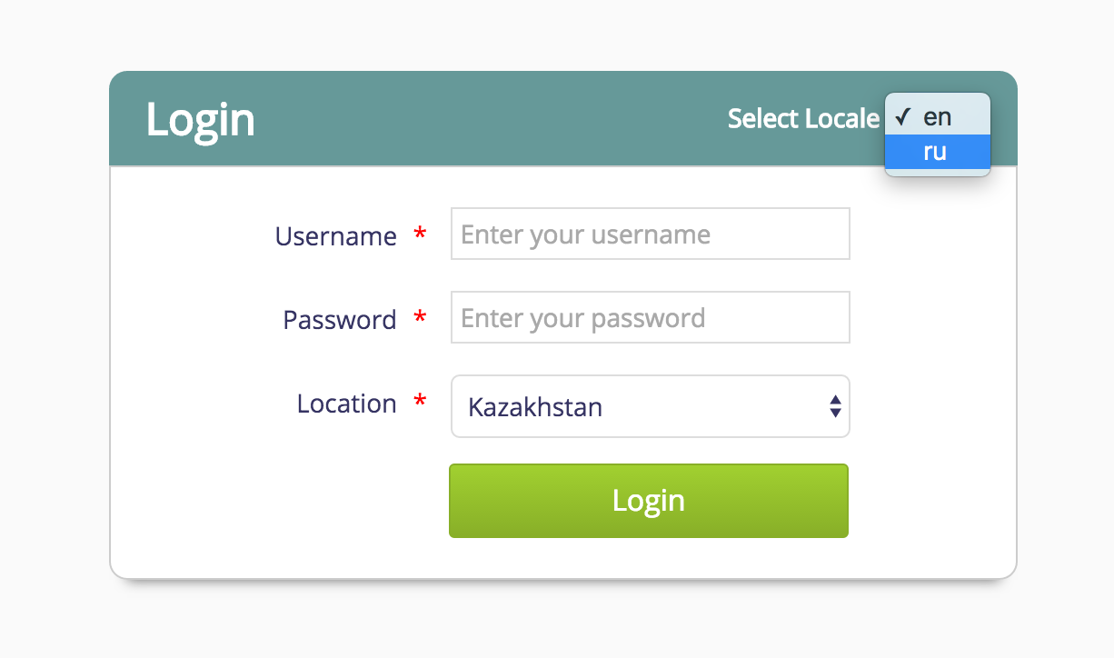
If you input an incorrect Username or Password, you will get the error message “You are not authenticated or your session expired. Please login”. If you get this type of error, double-check to make sure you have entered the correct Username and Password.

V. WELCOME PAGE
After logging in, the screen you will see is the welcome page/home page:
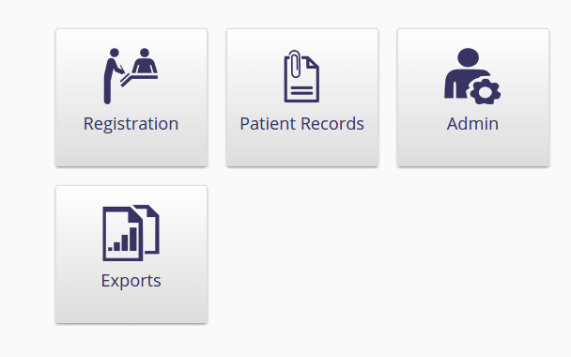

The welcome page consists of four apps: Registration, Patient Records, Admin, Exports. It is important to note that a user may not be able to see all four apps depending on the permissions and privileges he/she has been given in the system.

REGISTRATION
When you click on “Registration”, a page that allows you to search for an existing patient or create a new patient is opened:
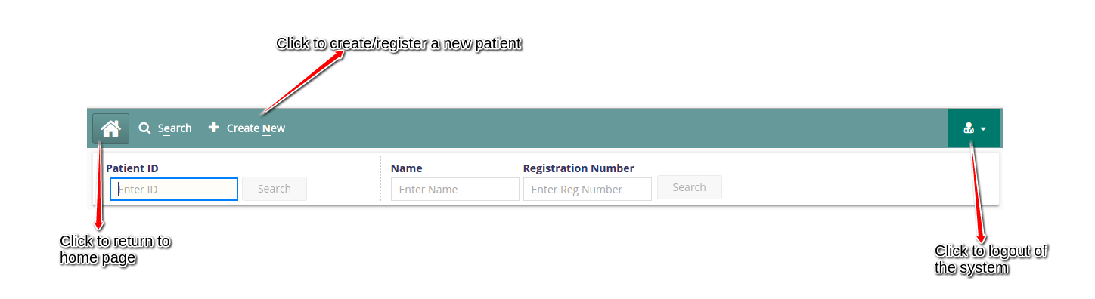

You can Search for an existing patient using the below patient attributes:
- Patient ID (i.e. endTB EMR ID)
- Patient Name
- Registration Number (i.e. Treatment Registration Number)

When searching for an existing patient using Patient ID, ensure that you have entered the correctly formatted and complete Patient ID (e.g. PER-0001-11111). Searching a patient using the complete ID takes you directly to the patient’s registration page once you hit the search button.

If you enter the country code only (e.g. LSO) in the Patient ID field and click search or hit enter, all the patients with that country code will be listed.

Once you find the patient(s), the following attributes are displayed:
- ID (Patient EMR ID)
- Name
- Gender
- Age
- Village
- Registration Date (Date patient registered in EMR)
- Registration Number (Treatment ID)

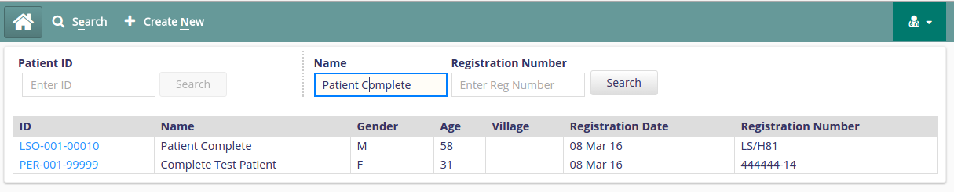
If you find the patient you are looking for and want to view his/her details, click on the ID in blue and you will be taken to the patient’s treatment details including all previously entered data, patient summary and be able to enter new data.

Again, if you want to logout of the system, click on the top right icon.

Create/Register a new patient
To register a new patient, click on the “+ Create New” button. The page below will open:
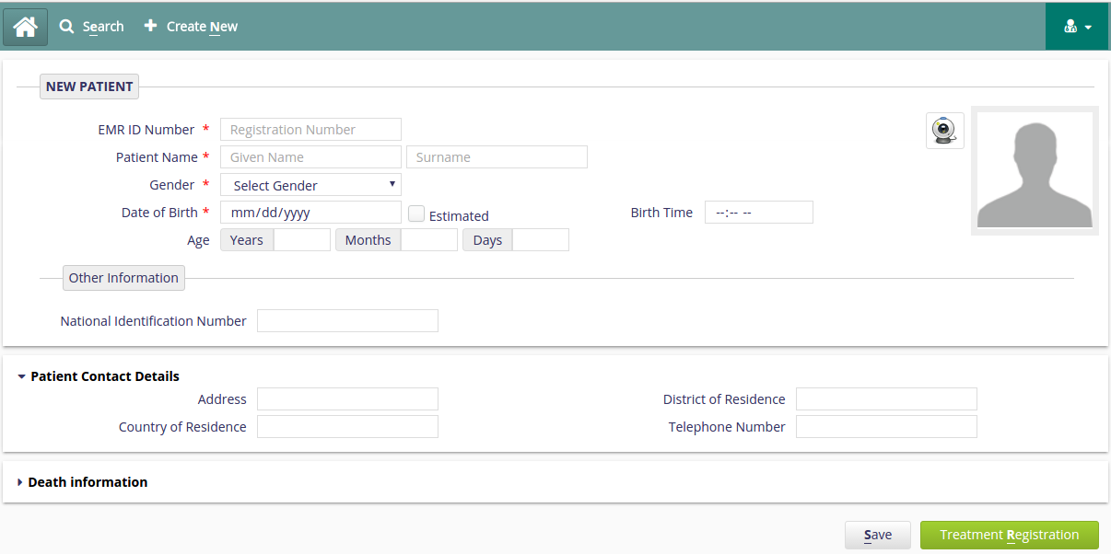

Data filled on this page is found on the baseline assessment form.

- All fields marked with a red star (asterisk *) are REQUIRED fields. If any field with the asterisk is left empty, data entered on that form will not be saved. On the registration page, the required fields are: EMR ID Number, Patient Name, Gender, Age, Date of Birth.
- All date entry fields are displayed as mm/dd/yyyy. Verify during date entry that these dates are being captured correctly because dates on the paper forms are displayed as DD/MMM/YYYY.
- EMR ID# is created as follows: Country ISO code (standard 3 letters) – Registration facility code (3 numbers assigned to the facility) – Consecutive patient code (5 numbers assigned to each patient, non repeating per registration facility). For example: LSO-001-00001. Note that the “-” should also be entered into the system or there will be an error message.
- Ensure that you are entering the correct EMR ID number. Once the number is saved into the system, the action can’t be undone. If you don’t enter the correct format of EMR ID number, data won’t be saved until you correct this error. The Image below shows the type of error you will get.
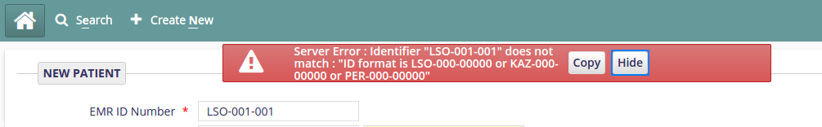
- For data entry and quality standards, Country ISO code should always be capitalized. The system does not do this automatically so verify the use of capital letters prior to saving.
- IGNORE THE DEATH INFORMATION SECTION. ALL OUTCOMES INFORMATION, INCLUDING DEATH, SHOULD BE FILLED OUT ON THE OUTCOME FORMS.

The image below highlights (using circles) the variables to be entered in the EMR registration page from the baseline assessment form.
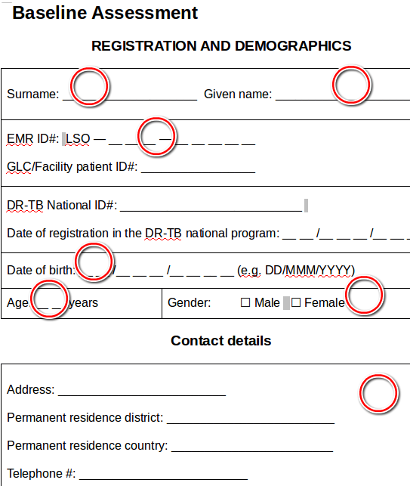

The fields to be entered into the Treatment Registration page from the baseline form are:
- EMR ID Number
- Patient Names(Given Name, Surname)
- Gender
- Date of Birth - If the Date of Birth is known and indicated on the forms always add the Date of Birth rather than the age. If date of birth is unknown but year of birth is known indicate the date of birth as 01/July/(known year); when month and year are known, indicate the date of birth as 01/(known month)/(known year).
- Age (DOB can auto populate Age and vice versa. It is important to note that if DOB is auto populated, it autopopulates the current date of data entry. If this is the case change date and month to the correct months on the baseline form, if there is no month or date on the paper form, check/click the Estimated box).
- The Contact details section on the baseline form is the Patient Contact Details section in the EMR.

After entering data into the registration page, Click on the “Save” button to save the newly created patient. Once your work is saved, click on the “Treatment Registration” to enroll a patient onto a treatment. Clicking on the Treatment Registration button can both save your patient and enroll them into a program.
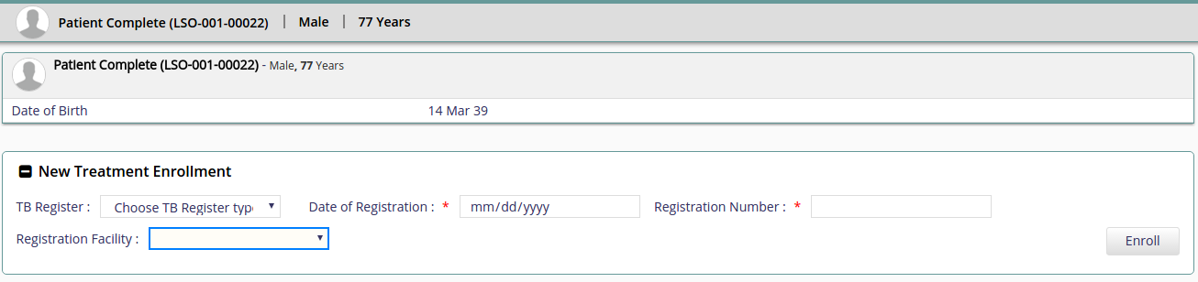
Registering a patient into a program
endTB patients are to be registered in the Second-line TB treatment register. To do this click on:
- New Treatment Enrollment.
- Choose TB Register type. This is a drop down button with values Basic management unit TB register and Second-line TB treatment register. A patient cannot be in two TB registers at the same time.
- The Date of Registration, Registration Number and Registration facility question are found on the baseline assessment form.
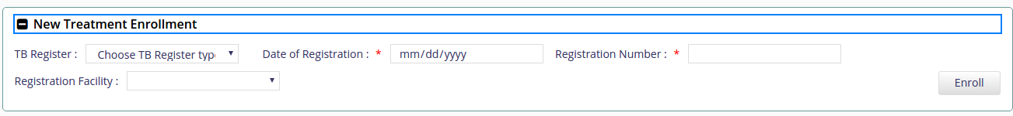
- Click on the Enroll button.

The image below highlights(using squares) the variables to be entered in the EMR’s new enrollment page from the baseline assessment form.

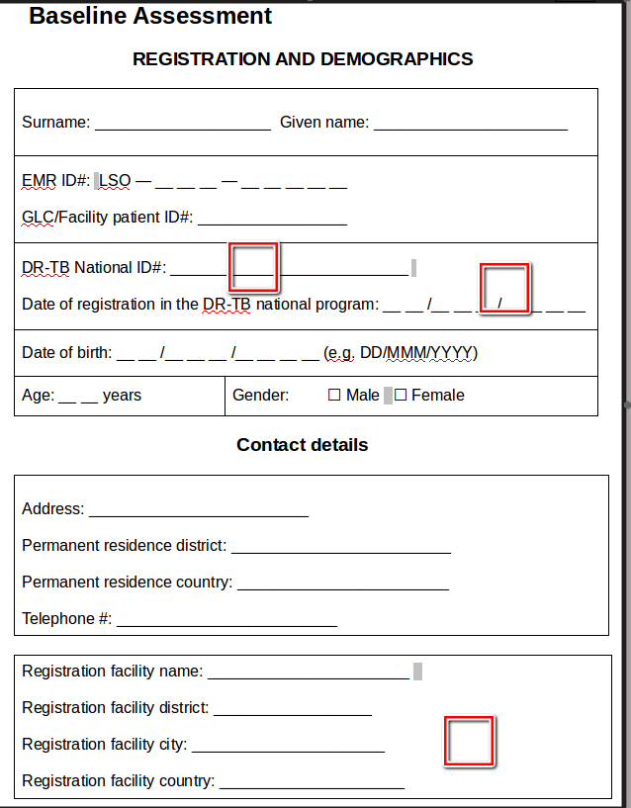
Once a patient is enrolled into a treatment, their information is displayed under Active Treatments.
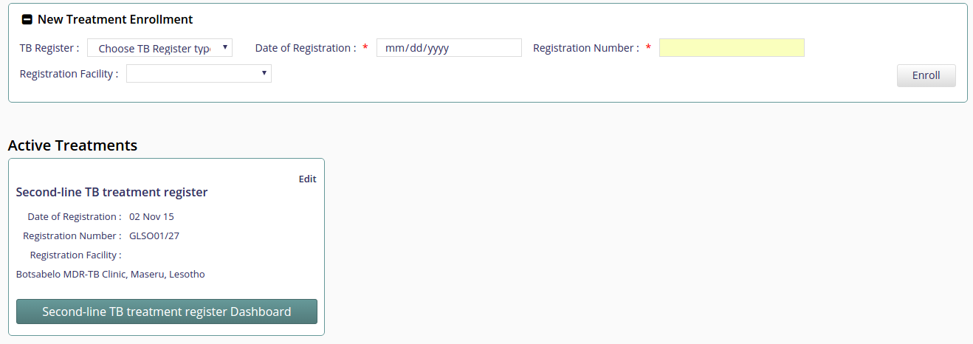
You can edit the above information by clicking on Edit(under Active Treatments).

Stopping a treatment.
To stop a treatment, click on edit(under Active Treatment) >> change the Treatment Status to Non Active.

Whether a patient is in Active treatment or Past Treatment, you should be able to view and access their dashboard, also the data can be edited.
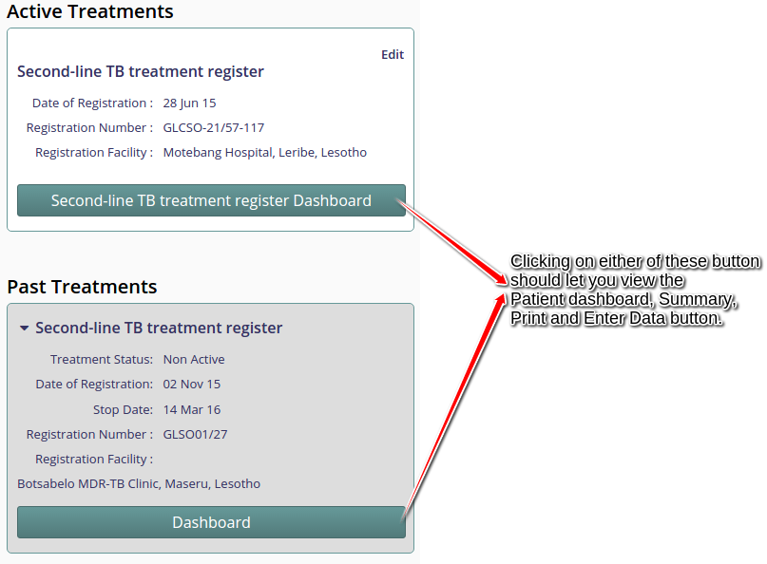

Accessing the patient’s dashboard and summary.
To access a patient’s summary and dashboard for the first time, you have to make sure that the patient is enrolled in an Active treatment. Once a patient is registered in a treatment, you click on “TB Register Type” Dashboard. Note that TB Register type should be the name of the treatment a patient is enrolled in. endTB patients will be enrolled in Second-line TB treatment, to access the patient dashboard and summary you will have to click on the Second-line TB treatment register Dashboard under Active Treatments.

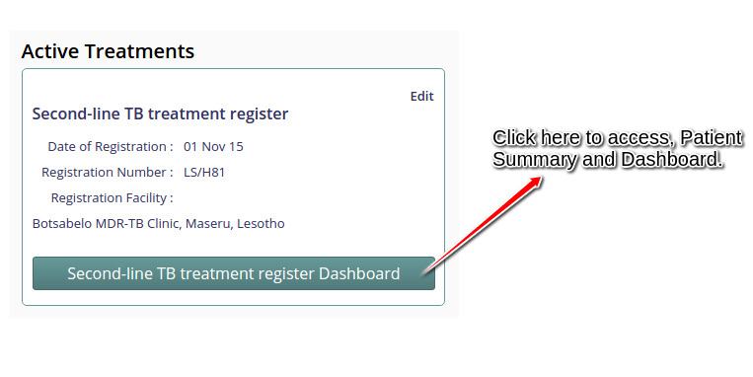

A patient’s dashboard lists the forms entered for a particular patient, all the active TB and Non TB drugs a patient is taking. Forms are grouped in categories on the dashboard. For example :-
Haematology, Biochemistry, Serology, Pregnancy, Xray, Audiometry, Electrocardiogram, Performance Status, …. Are all grouped under Lab and Test Results.

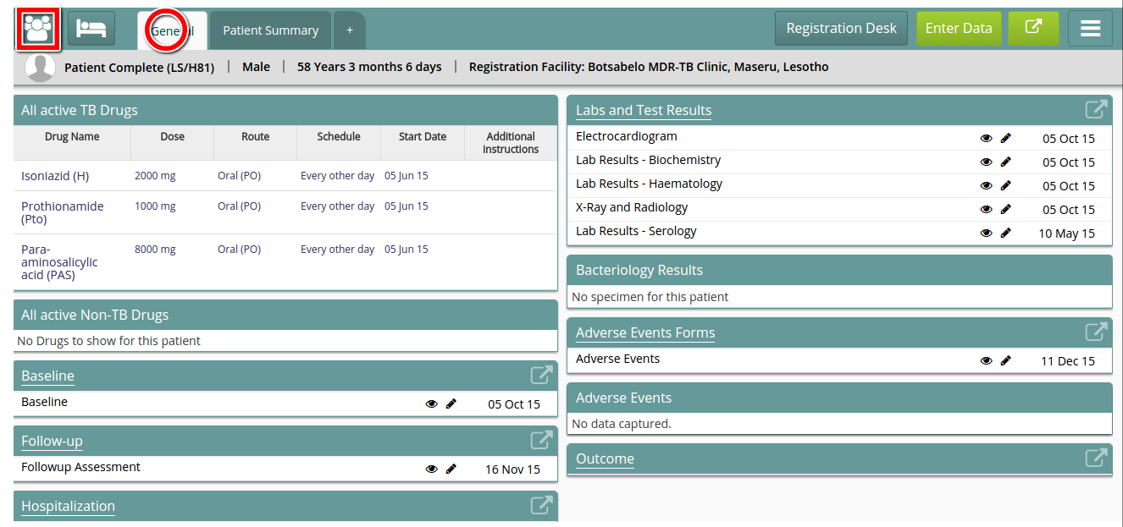

The patient dashboard is labeled as General in the EMR(tab highlighted using a circle object). To Navigate back and view the patient queue, click on the icon highlighted using a square box above.

The form group display control will only show the latest form entered (latest as in the newest date given among the forms. e.g. for follow-up form, its "Visit Date").

Click on underlined title to see all completed forms for visits completed by this patient during the specified treatment selected.

Patient Summary.
The patient summary is an important feature in the EMR. It briefly describes the important information in each and every endtb form thus giving a quick view of all patient's medical and personal details. This information can be printed on for clinical use.
Sample patient summary
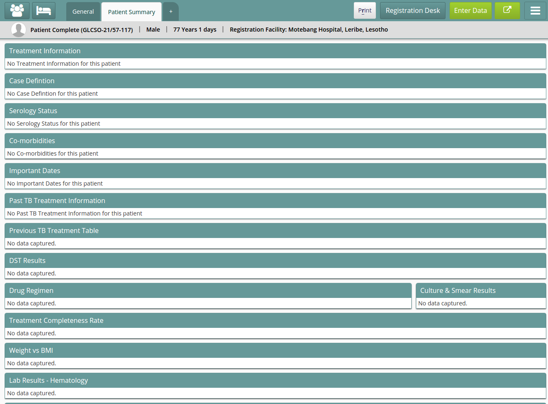

The above images show a patient summary. No data has been captured yet for the above patient, once data is captured the above section should be populated with recent patient's medical and personal details.

Accesing the endTB forms.

To access the endTB forms, click on the “Enter Data” button. All forms are collapsible and expandable by clicking on the arrow next to the title (e.g. “> Baseline”). You can expand a form that you want to enter data to.
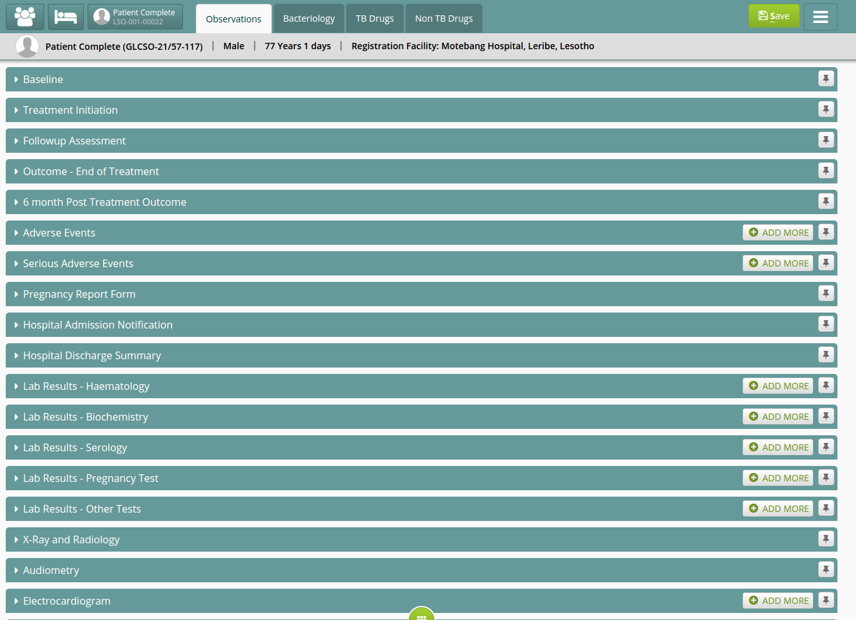

Some forms have the add more button. This button adds a similar form on the observations tab(for a particular patient).
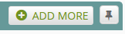

Entering and editing data.
. To enter data:
- Choose the form you want to enter into the EMR, expand it and enjoy entering data into it as indicated on the data forms

It is important to note that you should always save your work while entering data before navigating away from any section. To save the data you entered, click on the save button.
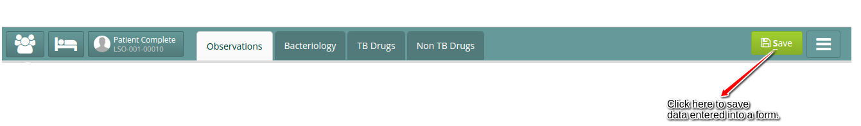

To edit an already entered data:
- You will need to access the form from the Patient Dashboard(General tab).
- To access the Patient Dashboard from the Observation tab; do the below(shown in the Image).
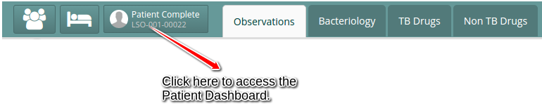

- Once you access the patient’s dashboard, you can edit a form by clicking on the underlined form name/group.
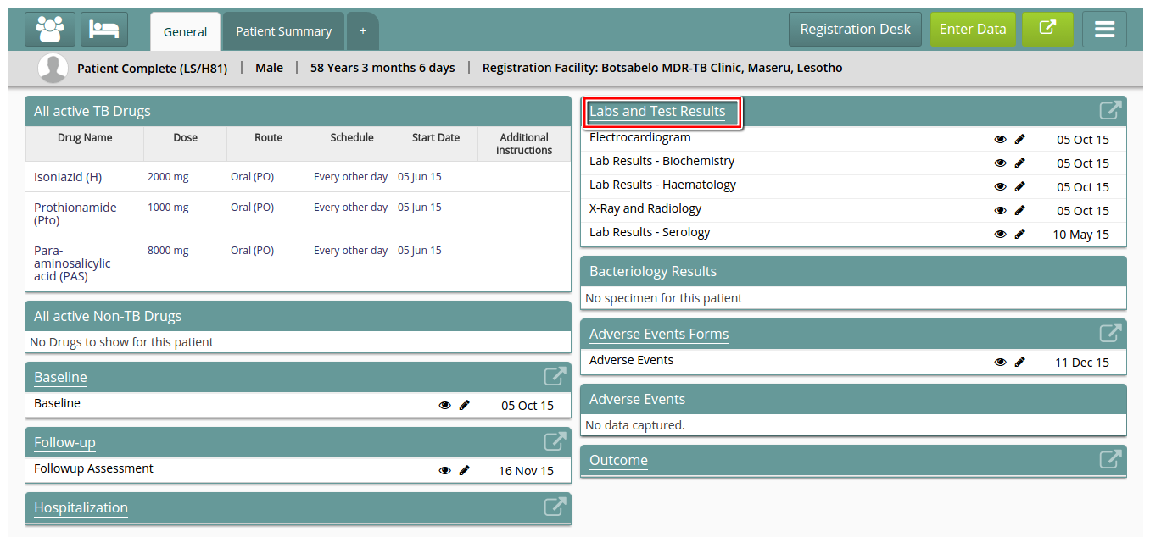

The above image shows how to edit an Electrocardiogram form which is classified in Labs and Test Results group.
- Click on Labs and Test Results(highlighted using a rectangular shaped object). This should give you the image below
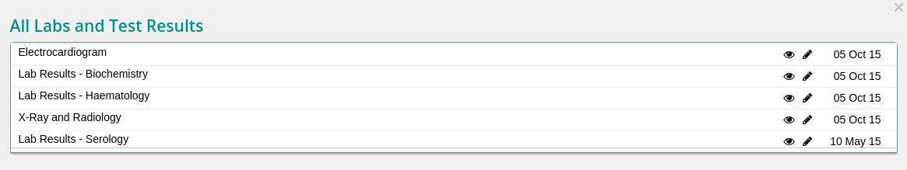

- Click on the pencil on the right hand side of Electrocardiogram. This should give you something similar to the below.
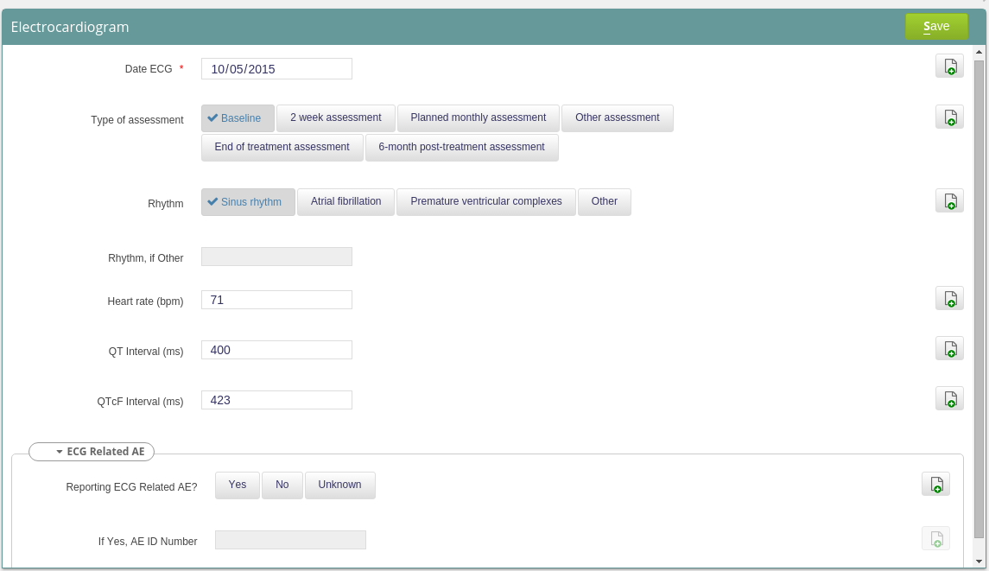

- Edit the fields you want to edit and remember to save your data, so that the changes are reflected in the system.

It is important to note that this is only done when editing a form that was already entered into the system. When editing a form ensure that you are editing the correct form by check if the date of that form matches the date on the paper form.

Forms explained.
Schedule of forms.
As shown below, forms are filled in a particular order by the clinician. It is important to know which forms a clinician should be able to give a data entry person so that they can enter data into the EMR.
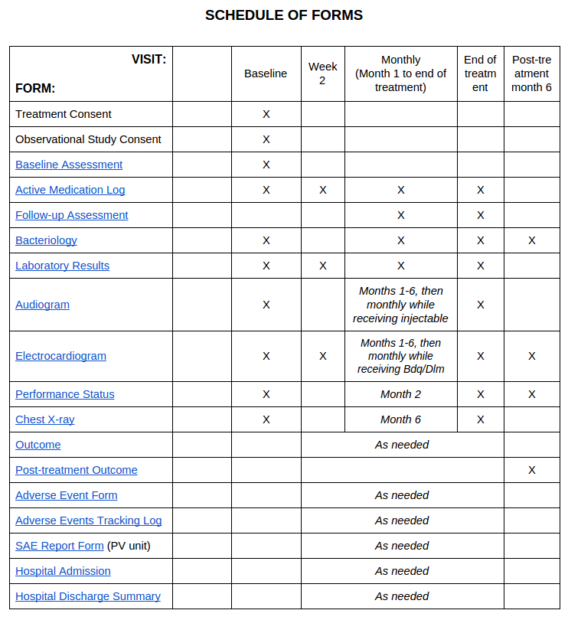

A form that has been filled in the EMR is displayed on the patient’s dashboard (General Tab). The explanations to edit a form are explained in the sections above.
In mosts of the form you will notice that
- Some questions in the EMR have a help button . Clicking on this button gives details about a particular question. For example clicking on the near the BPNS LEFT Pain, Ache, Burning show the full question as it is defined on the follow up paper form.

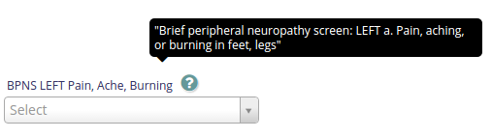
- Some questions have the button which is used to add important notes related to that question.

Baseline Form.
The baseline form contains multiple sections, in the EMR these section are expandable and collapsible.

The sections in collapsible format.
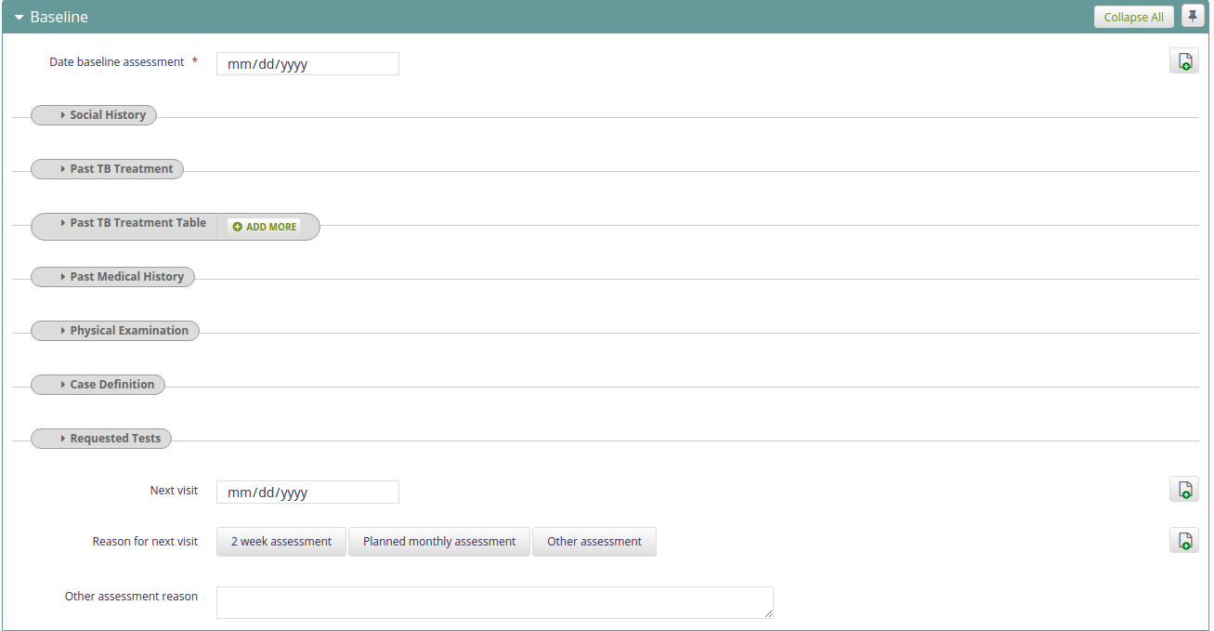

In the EMR, the names of the section is different for the names on the paper form. In the EMR we use defined short names such as the examples below.

Names of section on the Paper forms | Corresponding section names in the EMR
SOCIAL HISTORY | Social History
TB HISTORY | Past TB Treatment
PAST MEDICAL HISTORY (COMORBIDITIES) | Past TB Treatment Table
CLINICAL EXAMINATION | Physical Examination
CASE DEFINITION | Case definition
 | Required Tests
To expand a section in a form, click on the section name.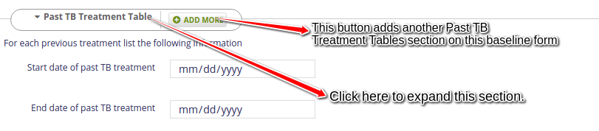
Some sections have the add more button.

Follow up Assessment
Patient’s followup forms are filled every month till the end of the treatment.

 | Assessment Date | Visit Date
 | Is the patient (if female) or the patient's (if male) partner currently pregnant? | Is patient or patient's partner pregnant?
 | If pregnant, PV pregnancy form case ID number | Pregnancy form case ID number
 | Brief peripheral neuropathy screen: LEFT  a. Pain, aching, or burning in feet, legs | BPNS LEFT pain, ache, burning
 | Brief peripheral neuropathy screen: LEFT  b. "Pins and needles" in feet, legs | BPNS LEFT pins needles
 | Brief peripheral neuropathy screen: LEFT  c. Numbness (lack of feeling) in feet, legs | BPNS LEFT numbness
 | Brief peripheral neuropathy screen: RIGHT  c. Numbness (lack of feeling) in feet, legs | BPNS RIGHT numbness
 | Brief peripheral neuropathy screen: vibration perception LEFT | BPNS LEFT vibration

Chest X-Ray and Radiology
This form is filled during baseline, month 6 and end of treatment. When the “Extent of Disease” question is marked as normal, the Maximum Cavity Size and Fibrosis questions should not be filled in the EMR. If these questions are filled on the paper form, please consult the clinician for more clarification.

Audiometry
This form is filled during baseline, patient monthly visit(month 1 to 6), end of treatment and more importantly every month when the patient is receiving an
injectable.
The intensity ranges from 0 db to 120 db. if there are amounts not in that range, please consult the clinician/ person responsible for filling out this form.
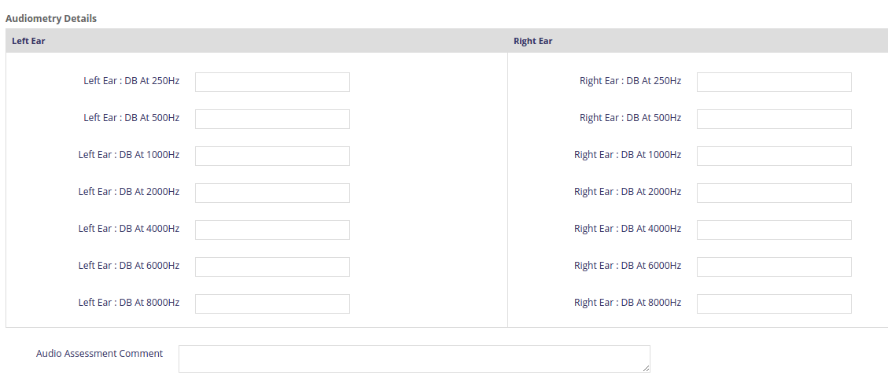

Electrocardiogram
This form is filled during the baseline assessment, second week of patient’s visit, month 1 to 6, end of treatment and 6 months after treatment.
Note that when a patient is receiving bedaquiline or delamanid this form is filled monthly.

Monthly treatment completeness
This form is filled every month

- Only complete one monthly completeness form.
- You can put in own calculation for monthly treatment completeness or enter the collected numbers (“a”, “b”, “c” and “d”) and the system will do the calculation (“e”, “Completeness Rate” and “Adherence Rate” under Monthly Calculations section) for you. If you do not enter any of “a”, “b”, “c” and “d”, then the system will not auto-calculate the Monthly calculation fields. And if “a” and “b” values are same, then the system will generate an error message. To not receive the error message you can add the value for “a” and “b” and leave “c” and “d” empty, and also enter the put your own values in Monthly calculations section. Note: provide the collected numbers and allow the system to do the calculation.

Performance Status form

This form is filled during baseline, 2nd month of treatment, end of treatment and 6 months after treatment.

Performance Status is a question with answers in a drop down box. Fill in the answer(value) the clinician has circled or ticked on the paper form. values for this question are:
0=Fully active 1=Restricted 2=Ambulatory 3=Capable 4=Completely disabled

Some variables on the patient forms are not included in the EMR. To avoid confusion, below is a list of variables that exist on the paper forms(v7) but not in the EMR.

Form | Section
Follow Up Assessment | Complaint/Reason for Visit
 | Physical Exam

SAE/AE
- Both AE and SAE ID’s can be input as a combination of numbers and letters (as needed)
- AE term is required for this form to be saved.
- When entering data for an AE or SAE there is a drop down box providing the most frequently used options. If you are unable to find the option that you would like to enter select ‘Other’ and provide further information in the text field that will become available.

Technical training.

To view all features and functionalities of bahmni, use google chrome as your browser. If you don’t have Chrome, download it from https://support.google.com/chrome/answer/95346?hl=en . Ensure that you are download the right chrome version for your machine(Either 32 or 64 bit).

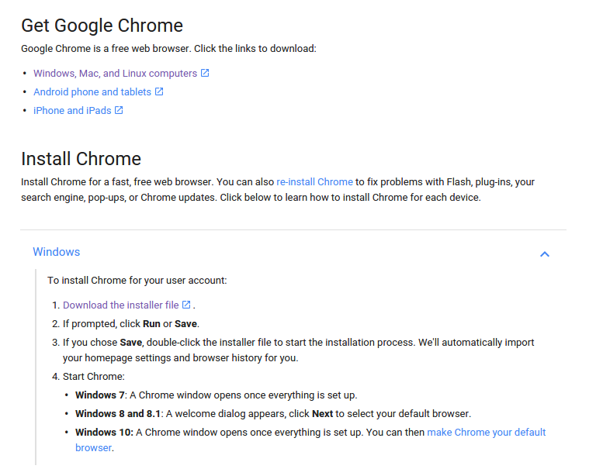

To log into the kazakhstan EMR browse
- https://kazakhstan.pih-emr.org

You will be prompted to accept the SSL configuration files.
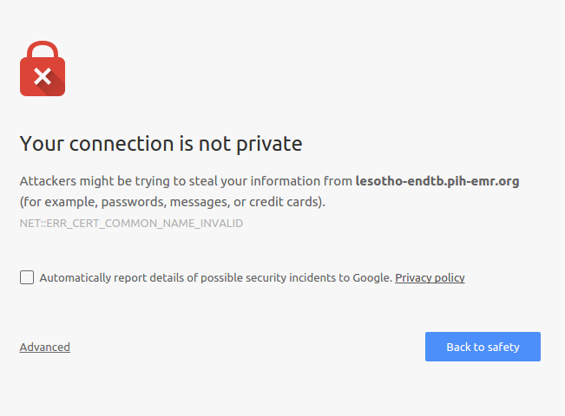

Click on Advanced
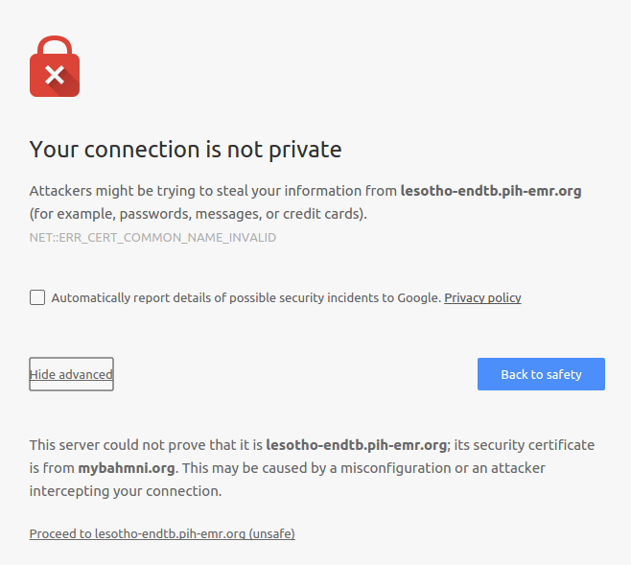

Click on Proceed to XXXX.pih-emr.org

For the Kazakhstan EMR, we have user accounts for 2 people:
- yekaterina_sahabutdinova -- Katya
- yerkebulan_algozhin -- Eric
- karamel_asel -- Karamel

The usernames on the testing server are the same with password endTBtest123.

Selecting locale: The endTB EMR has been translated to the Russian language.
To use the EMR in the Russian language; on the welcome page:
Select locale as ru.

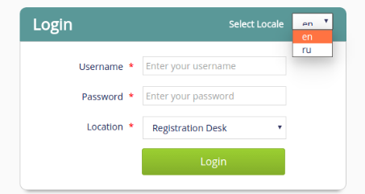

Logout
To logout of the system, click on the outermost icon on the right hand side of your page. Make sure to save your work before logging out of the system.
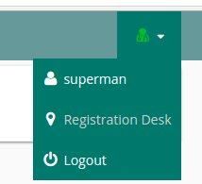
logout icon 1

Not all pages have the icon for the logout icon, on some pages you have to click on the home button to access the logout icon. (e.g if you are in the All Patients page).
The image below shows the home button circled(in red).
Logging out of the system from other web pages in the system is straightforward.
- Click on the outermost icon on the right hand side of your web page, the logout link is the last row.
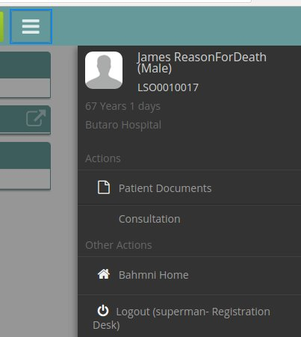
logout_icon2

